SUPPLEMENT
Capacity Planning

Discussion Questions
1. Design capacity is the theoretical maximum output of a system in a given period. Effective capacity is the capacity a firm can expect to achieve given its current product mix, methods of scheduling, maintenance, and standards of quality.
2. Effective capacity is the capacity a firm can expect to achieve given its current product mix, methods of scheduling, maintenance, and standards of quality.
3. Efficiency is the actual output as a percent of effective capacity.
Efficiency = Actual output/Effective capacity
4. Expected output = Effective capacity × Efficiency
5. Doubling capacity of a bottleneck only moves the bottleneck somewhere else; every system has at least one bottleneck. There would need to be a lot of excess capacity in the process for system capacity to double.
6. Process time of a system is the time of the longest (slowest) process, the bottleneck. Process cycle time is the time for a product to go through the production process with no waiting.
7. Theory of constraints is the body of knowledge that deals with anything that limits (constrains) an organization’s ability to achieve its goals.
8. The fundamental assumptions of break-even analysis are
- Fixed costs do not vary with volume
- Unit variable costs do not vary with volume
- Unit revenues do not vary with volume
9. Revenue data, when plotted, do not fall on a straight line because of volume discounts, changes in fixed cost, etc.
10. Lagging is preferred when short-term options like overtime and subcontracting are relatively low cost and/or easy to use. Leading is preferred when a firm cannot afford to lose customers for lack of product availability, and overtime, etc., are not available.
11. NPV determines the discounted or time value of money, comparing cost and income streams over periods of time. Process decisions may incur much of their expense early in the life of the equipment, but the stream of revenues may follow for decades. NPV is the appropriate analytical tool for that situation.
12. The five-step process that serves as a basis for the theory of constraints is:
1. Identify the constraints
2. Develop a plan for overcoming the identified constraints.
3. Focus resources on accomplishing Step 2.
4. Reduce the effects of the constraints by offloading work or by expanding capability.
5. When one set of constraints is overcome, go back to Step 1 and identify new constraints.
13. Techniques for dealing with bottlenecks include offloading some of the work to another workstation, increasing the capacity of the bottleneck, subcontracting, using alternative routings, and reducing setup times. Process cycle time is the time for a product to go through the production process; unless the bottleneck operation is made faster, process cycle time remains the same. (Alternative routing and subcontracting may expand the volume of units processed but not speed up the process cycle time.)
Active Model Exercises
Active Model S7.1: Productivity
1. Due to an anticipated decrease in demand the firm is considering
dropping one of its shifts. What will be the capacity if they do so?
134,400
2. Another option would be to maintain three shifts but only work on weekdays. What will be the capacity if they select this option?
144,000
3. As the effective capacity rises, how does this affect both the utilization and efficiency?
Utilization is unaffected but the efficiency drops.
4. As the actual output rises, how does this affect both the utilization and efficiency?
Both utilization and efficiency rise.
Active Model S7.2: Break-even Analysis
1. Use the scrollbars to determine what happens to the break-even point as the fixed costs increase? the variable costs increase? the selling price increases?
If the fixed or variable costs increase, then the break-even point increases; if the selling price increases, the break-even point decreases.
2. What is the percentage increase (over 5,714) to the break-even point if the fixed costs increase by 10% to $11,000? If the variable costs increase by 10% to $2.48? If the price per unit
increases by 10% to $4.40?
If the fixed costs rise by 10%, the break-even point rises by 10%. In this case, if the variable costs rise by 10%, then the BEP rises by 15%. If the price per unit increases by 10%, then the break-even point falls by 19%.
3. In order to cut the break-even point in half, by how much would the fixed costs have to decrease? the variable costs? How much would the selling price have to increase?
Fixed costs, $5,000; variable costs by $1.75 from $2.25
to $.50; the selling price would need to increase by the same $1.75.
End-of-Supplement Problems
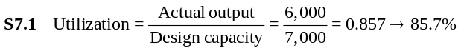
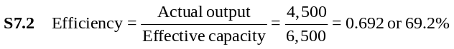
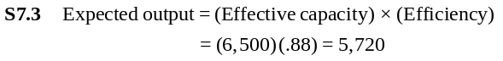
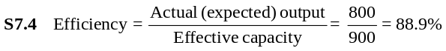
S7.5
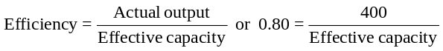
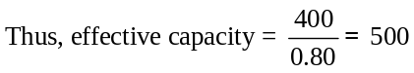
S7.6 Design: 93,600 × 0.95 = 88,920
Fabrication: 156,000 × 1.03 = 160,680
Finishing: 62,400 × 1.05 = 65,520
S7.7 Where:
Design capacity = 2,000 students
Effective capacity = 1,500 students
Actual output = 1,450 students
Therefore:
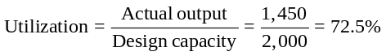
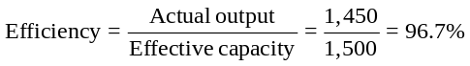
S7.8 Actual (or expected) output = (Effective capacity) (Efficiency) (Equation S7-3)
5.5 cars × 0.880 = 4.84 cars.

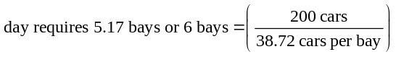Therefore, in one 8-hour day, one bay accommodates
(8 hr × 4.84 cars per hr) = 38.72 cars. To do 200 cars per

S7.9 Process time for Station 1 = 10 minutes; Process time for Station 2 = 12 / 2 = 6 minutes per unit; Process time for Station 3 = 8 minutes. Therefore, the bottleneck operation and the process time for the system is the largest of the three stations, Station 1, the maximum of 10, 6, and 8.
S7.10 Process time of each machine = 60 min./hr. ÷ 4 units/ hr. = 15 min./unit.
Process time of the work cell = Longest process time of each machine within the work cell = 15 min./unit. (Each of the machines can work on a different unit simultaneously.)
S7.11 Converting each capacity to a process time, Station 1 = 60 min./hr. ÷ 20 units/hr. = 3 min./unit (for both Machine A and Machine B); Station 2 = 60 min./hr. ÷ 5 units/hr. = 12 min./unit; and Station 3 = 60 min./hr. ÷ 12 units/hr. = 5 min./unit.
- Process time for the system (the bottleneck) is Station 2, at 12 min./unit.
- Bottleneck operation is Station 2, at 12 min. per unit.
- Both paths through the system have the same process cycle time = 3 + 12 + 5 = 20 minutes. (The parallel stations have no effect on process cycle time.)
- Weekly capacity = 60 min. × 10 hr. × 5 days / 12 min. at the bottleneck = 3,000 min./12 min. for each unit = 250 units per week
S7.12 Converting each capacity to a process time:
Station 1: Machine A = Machine B = 20 min./unit for each machine
Station 2 = 12 min./unit
Station 3 = 8 min./unit
- Process cycle time = 20 + 12 + 8 = 40 minutes
- Process time for Station 1 = 20 min. / 2 machines = 10 min./unit. So the system process time (the bottleneck) is the slowest station, which is Station 2, = 12 min./unit.
- Weekly capacity = (60 min./hr.)(8 hr./day)(6 days/wk.)/ (12 min./unit)
= 2,880 / 12 = 240 units/wk.
S7.13 (a) Both paths through the system have the same process cycle time = 20 + 12 + 8 = 40 minutes. (The parallel stations have no effect on process cycle time.)
(b) The process time for Station 1 = 20 min. / 2 machines = 10 min./unit, and the process time for Station 2 = 12 min. / 2 machines = 6 min./unit. The bottleneck is the slowest station, which is now Station 1 (10 min.), and the system process time for the assembly, the bottleneck = 10 min./unit.
(c) Weekly capacity = (60 min./hr.)(8 hr./day)(6 days/wk.) /
(1 unit/10 min.)
= 2,880 / 10 = 288 units/wk.
(d) The second machine at Station 2 moved the bottleneck to Station 1, with a process time of 10 minutes, which increased capacity from 240 to 288, or 48 units /wk.
S7.14 (a) Workstation C is the bottleneck, at 20 min./unit. (A different Part 1 can be worked on by Workstation A and Workstation B simultaneously.)
(b) Hourly capacity = 60 min./hr. ÷ 20 min./unit = 3 units/hr.
S7.15 (a) Converting each capacity to a process time,
Sawing = Sanding = 60 min./hr. ÷ 6 units/hr. = 10 min./unit;
Drilling = 60 min./hr. ÷ 2.4 units/hr. = 25 min./unit; Welding = 60 min./hr. ÷ 2 units/hr. = 30 min./unit; and each Assembly = 60 min./hr. ÷ 0.7 units/hr. = 85.71 min./unit. But the process time in overall Assembly = 85.71 / 3 = 28.57 min./unit. Therefore, the bottleneck is the slowest station, which is Welding, at 30 min./unit.
(b) Process time for the system (system process time) = Process time for the bottleneck = 30 min./unit.
(c) Process cycle time (time for a unit to go through the system) = Maximum of (10 + 10 + 30 + 85.71, or 25 + 30 + 85.71) = Maximum of (135. 71 or 140.71) = 140.71 min.
(d) Monthly capacity = (60 min./hr.)(8 hr./day)(20 days/month) / (1 unit/30 min.) = 9,600/30 = 320 units/month.

S7.16 Break-even:

- Break-even in units = 2,000 units
- Break-even in dollars = (P)(BEP_{x}) = ($0.75)(2,000)
= $1,500

S7.17 (a) Proposal A break-even in units is:
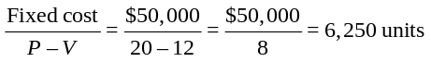
(b) Proposal B break-even in units is:
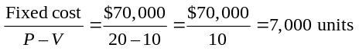
S7.18 (a) Proposal A break-even in dollars is:
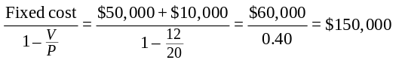(b) Proposal B break-even in dollars is:
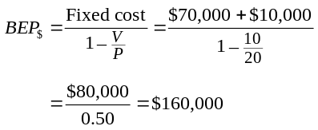
S7.19 Set Proposal A = Proposal B
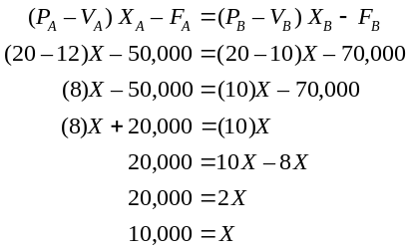
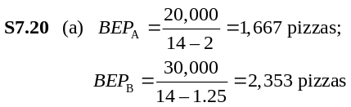
(b, c) For both quantities, oven A is slightly more profitable (but oven B is catching up).

 | Oven A | Oven B | Unit Sales of
Fixed cost | $20,000.00 | $30,000.00 |  | Profit A— | Profit B—
Revenue | $14.00 | $14.00 | 9,000 → | $88,000 | $84,750
Variable cost | $2.00 | $1.25 | 12,000 → | $124,000 | $123,000

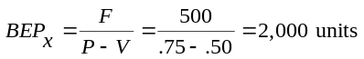
(d) 20,000 + 2Xa = 30,000 + 1.25Xb
.75X = 10,000
X = 13,333 pizzas

S7.21 Given:
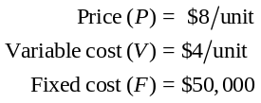
(a) Break-even in units is given by:
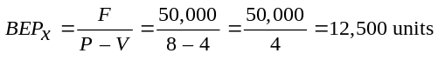
(b) Break-even in dollars is given by:
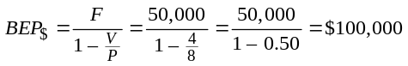
(c) Profit is given by:
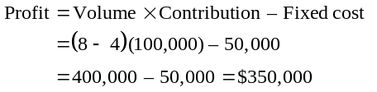
S7.22 Given:
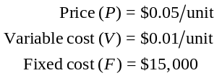
Break-even is given by:
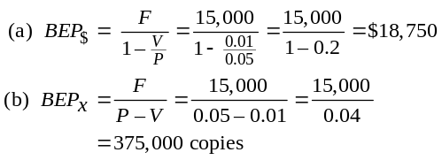
S7.23 Option A: Stay as is
Option B: add new equipment
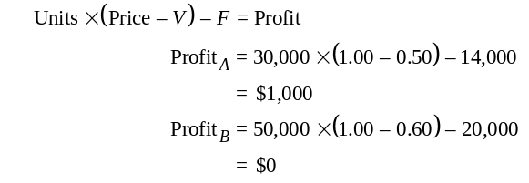Therefore, the company should stay with the current equipment.

S7.24 Option A: Stay as is
Option B: Add new equipment, raise selling price
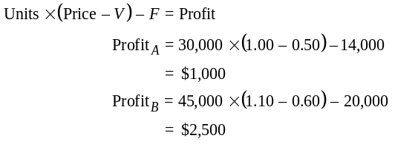
Therefore, the company should choose option B: add the new equipment and raise the selling price.
S7.25 Where:
F = $37,500 V = $1.75 P = 2.50
(a) Break-even quantity for the manual process in units:
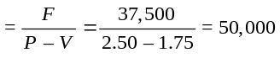bags
(b) Revenue at the break-even quantity for the manual process:
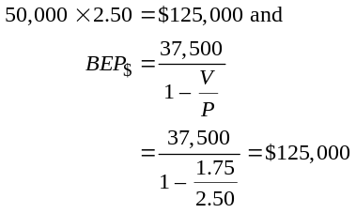
(c) Break-even quantity for the mechanized process: where: F = 75,000 P = 2.50 V = 1.25
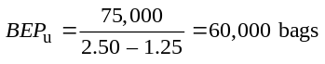
(d) Revenue at the break-even quantity for the mechanized process:
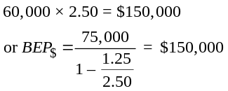
(e) Monthly profit or loss of the manual process if they expect to sell 60,000 bags of lettuce per month:
Profit = 2.50(60,000) – 1.75(60,000) – 37,500 = $7,500
(f) Monthly profit or loss of the mechanized process if they expect to sell 60,000 bags of lettuce per month
2.50(60,000) – 1.25(60,000) – 75,000
= 0.0 (break-even)
(g) They should be indifferent to the process selected at 75,000 bags.
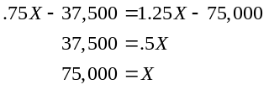
(h) The manual process be preferred over the mechanized process below 75,000 bags. The mechanized process be preferred over the manual process above 75,000 bags.
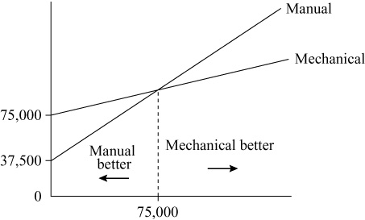

S7.26 (a) Break-even volume:
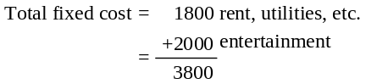
 | Selling  Price | Volume | Revenue |  | Percent of  Total Revenue
Drinks | 1.50 | 30,000 | 45,000 |  | 0.153
Meals | 10.00 | 10,000 | 100,000 |  | 0.339
Desserts etc. | 2.50 | 10,000 | 25,000 |  | 0.085
Sandwiches | 6.25 | 20,000 | 125,000 |  | 0.423
 |  |  |  | 295,000 |  | 1.000

 | P | V | V/P | 1–V/P | W_{i} |  |  | 1–(V/P)W_{i}
Drinks | 1.50 | 0.75 | 0.50 | 0.50 | 0.153 |  |  | 0.077
Meals | 10.00 | 5.00 | 0.50 | 0.50 | 0.339 |  |  | 0.170
Desserts | 2.50 | 1.00 | 0.40 | 0.60 | 0.085 |  |  | 0.051
Lunch | 6.25 | 3.25 | 0.52 | 0.48 | 0.423 |  |  | 0.203
 |  |  |  |  |  | 1.000 |  |  | 0.501
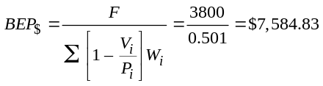
(b) Number of meals per day at break-even = 9
 | Selling  Price | Fraction  of Total  Revenue | Dollar  Volume | BE Units  per  Month | BE Units  per  Day
Drinks | 1.50 | 0.153 | 1,160.48 | 774→ | 26
Meals | 10.00 | 0.339 | 2,571.26 | 258→ | 9
Desserts etc. | 2.50 | 0.085 | 644.71 | 258→ | 8
Sandwiches | 6.25 | 0.424 | 3,208.28 | 514→ | 18

S7.27 (a) Break-even volume, where total fixed cost = labor
(at $250) + booth rental (at 5 × $50) = $500.
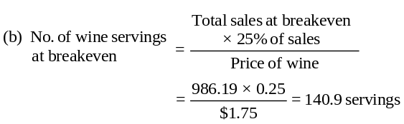
S7.28
Item | (P)  Selling  Price | (V)  Variable  Cost | Var. Cost  Factor (%) | Total  Var. Cost | 1 – (V/P) | Estimated  Percent  Revenue |  |  | Contribution  Weighted  Revenue
Soft drinks | 1.00 | 0.65 | 1.1 | 0.715 | 0.285 | 0.25 |  |  | 0.071
Wine | 1.75 | 0.95 | 1.1 | 1.045 | 0.403 | 0.25 |  |  | 0.101
Coffee | 1.00 | 0.30 | 1.1 | 0.330 | 0.670 | 0.30 |  |  | 0.201
Candy | 1.00 | 0.30 | 1.1 | 0.330 | 0.670 | 0.20 |  |  | 0.134
Totals |  |  |  |  |  |  | 1.00 |  |  | 0.507
Break-even = TFC/wt contribution = 500/0.507 = $986.19
Option A: EMV = (90,000 × .5) + (25,000 × .5) = 45,000 + 12,500
= $57,500
Option B: EMV = (80,000 × .4) + (70,000 × .6) = 32,000 + 42,000
= $74,000
Option C: EMV = (60,000 × .3) + (55,000 × .7) = 18,000 + 38,500
= $56,500
Therefore, Option B (modernize 2nd) has the highest EMV.
Decision tree solution:

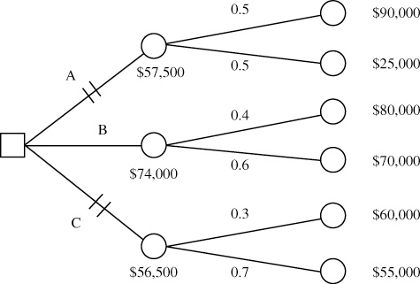
Again, Branch B, which represents Option B-Modernize 2nd floor, has the highest expected value, $74,000.
S7.29
EMV for large line = [(Sales–Cost) × 2/3] + [(Sales–Cost) × 1/3]
= (200,000 × 2/3) + (–100,000 × 1/3) = $100,000
EMV for small line and no expansion = [(Sales–Cost) × 1/3]
+ [(Sales–Initial cost) × 2/3]
= [(300,000–300,000) × 1/3] + [(400,000–300,000) × 2/3]
= $0.0 + $66,666 = $66,666.
Therefore, build a large line.

Decision tree solution:
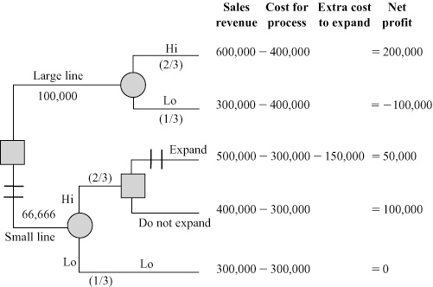
Prefer to build a large line. Large line has a payoff of
$100,000. Small line has a payoff of $66,666 + 0 = $66,666.
S7.30
Initial investment = $75,000
Salvage value = $45,000
Five-year return = $15,000
Cost of capital = 12%
NPV annuity factor → 5 years @ 12% = 3.605
Present value = 3.605 × 15,000 = $54,075
Present value of salvage: 0.567 × 45,000 = $25,515
Net present value = 54,075 + 25,515 – 75,000 = $4,590
S7.31
Initial investment = $65,000
Eight-year return = $16,000 per year
Cost of capital = 10%
NPV annuity factor → 8 years @ 10% = 5.335
Present value = 5.335 × $16,000 = $85,360
Net present value = $85,360 – $65,000 = $20,360
S7.32
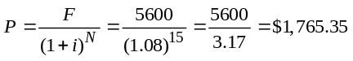
or from Table S7.1:
NPV = F × PVF8%, 15 = 5600 × 0.315 = $1,764

S7.33
Expense | Machine A | Machine B
Original cost | 10,000 | 20,000
Labor per year | 2,000 | 4,000
Maintenance per year | 4,000 | 1,000
Salvage value | 2,000 | 7,000

Year |  | Machine A | NPV Factor* | NPV
Now | Expense | 10,000 | 1.000 | –10,000
1 | Expense | 6,000 | 0.893 | –5,358
2 | Expense | 6,000 | 0.797 | –4,782
3 | Expense | 6,000 | 0.712 | –4,272
 |  |  |  | –24,412
3 | Salvage revenue | 2,000 | 0.712 | +1,424
 |  |  |  | –22,988
* NPV factor from Table S7.1.
Year |  | Machine B | NPV Factor* | NPV
Now | Expense | 20,000 | 1.000 | –20,000
1 | Expense | 5,000 | 0.893 | –4,465
2 | Expense | 5,000 | 0.797 | –3,985
3 | Expense | 5,000 | 0.712 | –3,560
 |  |  |  | –32,010
3 | Salvage revenue | 7,000 | 0.712 | +4,984
 |  |  |  | –27,026
* NPV factor from Table S7.1.
NPV for Machine A is –$22,988; NPV for Machine B is –$27,026. Therefore, Machine A should be recommended.
S7.34
Expense | Three Small Ovens | Two Large Ovens
Original cost | 3,750 | 5,000
Excess labor per year | 750 | 0
Maintenance per year | 750 | 400
Salvage value | 750 | 1,000

Year |  | Three Small Ovens  NPV Factor* |  | NPV
Now | Expense | 3,750 | 1.000 | –3,750
1 | Expense | 1,500 | 0.877 | –1,316
2 | Expense | 1,500 | 0.769 | –1,154
3 | Expense | 1,500 | 0.675 | –1,013
4 | Expense | 1,500 | 0.592 | –888
5 | Expense | 1,500 | 0.519 | –779
 |  |  |  | –8,900
5 | Salvage revenue | 750 | 0.519 | +389
 |  |  |  | –8,511
* NPV factor from Table S7.1.

Year |  | Two Large Ovens  NPV Factor* |  | NPV
Now | Expense | 5,000 | 1.000 | –5,000
1 | Expense | 400 | 0.877 | –351
2 | Expense | 400 | 0.769 | –308
3 | Expense | 400 | 0.675 | –270
4 | Expense | 400 | 0.592 | –237
5 | Expense | 400 | 0.519 | –208
 |  |  |  | –6,374
5 | Salvage revenue | 1,000 | 0.519 | +519
 |  |  |  | –5,855
* NPV factor from Table S7.1 for 14%.
(a) NPV of the three small ovens = –$8,511; NPV of the two large ovens = –$5,855. Therefore, you should recommend that the firm purchase the two large ovens.
(b) The basic assumptions made with regard to the ovens are:
- The ovens are of equal quality.
- The ovens are of equivalent production capacity.
(c) The basic assumptions made with regard to methodology are:
- Future interest rates are known.
- Payments are made at the end of each time period.
S7.35 (a) Remember that Year 0 has no discounting.
Initial cost = $1,000,000 Yearly maintenance = $75,000
Salvage cost = $50,000 Yearly dues = $300,000
Interest rate = 0.10 No. of members = 500
Annual dues/member = $600
Year | Cost | Revenues | Profit | PV of $1 | NPV
0 | $1,075,000 | $300,000 | –$775,000 | 1.00 | –$775,000
1 | 75,000 | 300,000 | 225,000 | .909 | $204,525
2 | 75,000 | 300,000 | 225,000 | .826 | $185,850
3 | 75,000 | 300,000 | 225,000 | .751 | $168,975
4 | 75,000 | 300,000 | 225,000 | .683 | $153,675
5 | 75,000 | 350,000 | 275,000 | .621 | $139,725
 | Undisc. Profit $400,000 |  |  | PV Profit $77,750

Assume that dues are collected at the beginning of each year. This is a simplification; in reality, people are likely to join throughout the year.
(b) Special deal comparison: $3,000 for all six years. Compare the PV cash stream of yearly dues from one member to that of the deal. Since we specified the club will always be full, we can make the assumption that the member (or her replacement) will always be paying the annual fee.
Initial cost = $0 Yearly maintenance = $0
Salvage cost = $0 Yearly dues = $600
Interest rate = 0.10

 |  | (Membership Fee)
Year | Cost | Revenues | Profit | PV of $1 | NPV
0 | $0 | $600 | $600 | 1.000 | $600
1 | 0 | 600 | 600 | .909 | $545
2 | 0 | 600 | 600 | .826 | $496
3 | 0 | 600 | 600 | .751 | $451
4 | 0 | 600 | 600 | .683 | $410
5 | 0 | 600 | 600 | .621 | $373
 |  | Undisc. Profit $3,600 |  | PV Profit $2,274
Because this is less than $3,000, the special deal is worth more to the health club. Note also: If health club member is using same interest rates, it’s better for her to pay yearly.

Additional Homework Problems
Here are solutions to additional homework problems that appear on our Web site. www.pearsonglobaleditions.com/myomlab.
S7.36 (a) Proposal A breakeven in units is:
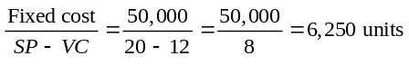
(b) Proposal B breakeven in units is:
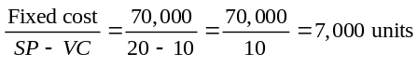

S7.37 (a) Proposal A breakeven in dollars is:
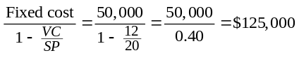
(b) Proposal B breakeven in dollars is:
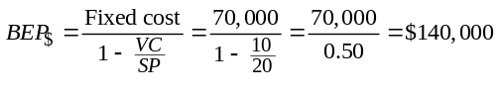
S7.38 Set Proposal A = Proposal B; Solve for units
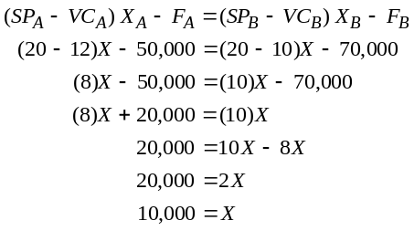
S7.39 (a) Proposal A: Profit at 8,500 units
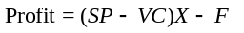
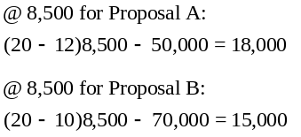
Proposal A is best.
(b) Proposal B: Profit at 15,000 units
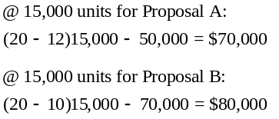
Proposal B is best.
S7.40 Investment A net income, using Table S7.2, and interpolating between 8% and 10%; 19000 × PVF9%, 6 – 61,000 = 19,000 × 4.486 – 61,000 = $24,234

Investment B Net Income
Year |  |  | NPV Factor* | NPV
Now | Expense | 74,000 | 1.000 | –74,000
1 | Revenue | 19,000 | 0.917 | +17,423
2 | Revenue | 20,000 | 0.842 | +16,840
3 | Revenue | 21,000 | 0.772 | +16,212
4 | Revenue | 22,000 | 0.708 | +15,576
5 | Revenue | 21,000 | 0.650 | +13,650
6 | Revenue | 20,000 | 0.596 | +11,920
7 | Revenue | 11,000 | 0.547 | +6,017
 |  |  |  | 23,638
* Interpolating between 8% and 10% in Table S7.1
Therefore, Investment A, with a payoff of $24,234, would be preferred over Investment B, with a payoff of $23,638.

S7.41 Initial investment = $20,000
Cash Flows
 | NPV | Cash Flow 1 |  | Cash Flow 2 |  |  |  |  |  | Cash Flow 3
Year | Factor* | Cash | P | Cash | P |  |  |  |  | Cash |  |  | P
1 | 0.909 | $1,000 | $909 | $7,000 | $6,363 |  |  |  | $10,000 |  |  |  | $9,090
2 | 0.826 | 1,000 | 826 | 6,000 | 4,956 |  |  |  | 5,000 |  |  |  | 4,130
3 | 0.751 | 3,000 | 2,253 | 5,000 | 3,755 |  |  |  | 3,000 |  |  |  | 2,253
4 | 0.683 | 15,000 | 10,245 | 4,000 | 2,732 |  |  |  | 2,000 |  |  |  | 1,366
5 | 0.621 | 3,000 | 1,863 | 4,000 | 2,484 |  |  |  | 1,000 |  |  |  | 621
6 | 0.564 | 1,000 | 564 | 4,000 | 2,256 |  |  |  | 1,000 |  |  |  | 564
7 | 0.513 | — | — | 4,000 | 2,052 |  |  |  | 1,000 |  |  |  | 513
8 | 0.467 | 1,000 | 467 | 2,000 | 934 |  |  |  | — |  |  |  | —
9 | 0.424 | — | — | — | — |  |  |  | 1,000 |  |  |  | 425
 |  |  | $17,127 |  |  | $25,532 |  |  |  |  |  | $18,962
*The NPV from investment 2 is highest, at $5,532 (after initial investment of $20,000 is subtracted).

S7.42 At 11 percent, the net present value is –$7,677.89. At 4 percent, the net present value is $5,378.54. They should purchase at 4 percent but not at 11 percent.
 |  |  | Vinyl Siding Machine Solution at 11%
 |  |  |  |  |  | PV Factor |  |  |  |  |  |  |  | PV
 | Inflow |  |  | Outflow |  | at 11%* | PV Inflow |  |  | PV Outflow |  |  |  | (Inflow–Outflow)
Period 0 | 0 |  |  | 70,000 |  | 1 | 0 |  |  | 70,000 |  |  |  | –70,000
Period 1 | 20,000 |  |  | 0 |  | 0.9009 | 18,018.02 |  |  | 0 |  |  |  | 18,018.02
Period 2 | 15,000 |  |  | 0 |  | 0.8116 | 12,174.34 |  |  | 0 |  |  |  | 12,174.34
Period 3 | 15,000 |  |  | 0 |  | 0.7312 | 10,967.87 |  |  | 0 |  |  |  | 10,967.87
Period 4 | 15,000 |  |  | 0 |  | 0.6587 | 9,880.96 |  |  | 0 |  |  |  | 9,880.96
Period 5 | 10,000 |  |  | 0 |  | 0.5935 | 5,934.51 |  |  | 0 |  |  |  | 5,934.51
Period 6 | 10,000 |  |  | 0 |  | 0.5346 | 5,346.40 |  |  | 0 |  |  |  | 5,346.40
Total |  | 85,000 |  |  | 70,000 |  |  | 62,322.11 |  |  | 70,000 |  |  |  | –7,677.89
* Interpolated between 10% and 12% in Table S7.1.
S7.43 The net present value of the receipts is $89,711.58.
 | Vinyl Siding Machine Solution at 4%
 |  |  |  | PV Factor |  |  |  |  |  |  | PV
 | Inflow | Outflow |  | at 4% | PV Inflow |  |  | PV Outflow |  |  | (Inflow–Outflow)
Period 0 | 0 | 70,000 |  | 1 | 0 |  |  | 70,000 |  |  | –70,000
Period 1 | 20,000 | 0 |  | 0.9615 | 19,230.77 |  |  | 0 |  |  | 19,230.77
Period 2 | 15,000 | 0 |  | 0.9246 | 13,868.34 |  |  | 0 |  |  | 13,868.34
Period 3 | 15,000 | 0 |  | 0.889 | 13,334.95 |  |  | 0 |  |  | 13,334.95
Period 4 | 15,000 | 0 |  | 0.8548 | 12,822.06 |  |  | 0 |  |  | 12,822.06
Period 5 | 10,000 | 0 |  | 0.8219 | 8,219.27 |  |  | 0 |  |  | 8,219.27
Period 6 | 10,000 | 0 |  | 0.7903 | 7,903.14 |  |  | 0 |  |  | 7,903.14
Total | 85,000 |  | 70,000 |  |  | 75,378.54 |  |  | 70,000 |  |  |  | 5,378.539

 |  |  |  |  |  | PV Factor
 | Inflow |  | Outflow |  |  | at 6% | Present value
Period 0 | 0 |  | 1 |  |  | 0 | 0
Period 1 | 50,000 |  | 0 |  |  | 0.9434 | 47,169.81
Period 2 | 30,000 |  | 0 |  |  | 0.89 | 26,699.89
Period 3 | 0 |  | 0 |  |  | 0.8396 | 0
Period 4 | 20,000 |  | 0 |  |  | 0.7921 | 15,841.87
Total |  | 100,000 |  | 0 |  |  |  | 89,711.58

S7.44 Machine A’s NPV is $81,323.16; machine B’s NPV is $85,982.66. Machine B has the higher NPV. The lower annual returns are more than offset by a lower initial cost and by the
salvage value.

Milling |  |  |  |  |  |  | PV Factor |  |  |  |  |  |  | PV
Machine A | Inflow |  |  | Outflow |  |  | at 7%* | PV Inflow |  |  | PV Outflow |  |  | (Inflow–Outflow)
Period 0 | 0 |  |  | 300,000 |  |  | 1 | 0 |  |  | 300,000 |  |  | –300,000
Period 1 | 80,000 |  |  | 0 |  |  | 0.9346 | 74,766.35 |  |  | 0 |  |  | 74,766.35
Period 2 | 80,000 |  |  | 0 |  |  | 0.8734 | 69,875.09 |  |  | 0 |  |  | 69,875.09
Period 3 | 80,000 |  |  | 0 |  |  | 0.8163 | 65,303.83 |  |  | 0 |  |  | 65,303.83
Period 4 | 80,000 |  |  | 0 |  |  | 0.7629 | 61,031.62 |  |  | 0 |  |  | 61,031.62
Period 5 | 80,000 |  |  | 0 |  |  | 0.713 | 57,038.89 |  |  | 0 |  |  | 57,038.89
Period 6 | 80,000 |  |  | 0 |  |  | 0.6663 | 53,307.38 |  |  | 0 |  |  | 53,307.38
Total |  | 480,000 |  |  | 300,000 |  |  |  | 381,323.20 |  |  | 300,000 |  |  | 81,323.16
* Interpolated between 6% and 8% in Table S7.1.

Milling |  |  |  |  |  |  | PV Factor |  |  |  |  |  |  | PV
Machine B | Inflow |  |  | Outflow |  |  | at 7%* | PV Inflow |  |  | PV Outflow |  |  | (Inflow–Outflow)
Period 0 | 0 |  |  | 220,000 |  |  | 1 | 0 |  |  | 220,000 |  |  | –220,000
Period 1 | 60,000 |  |  | 0 |  |  | 0.9346 | 56,074.77 |  |  | 0 |  |  | 56,074.77
Period 2 | 60,000 |  |  | 0 |  |  | 0.8734 | 52,406.32 |  |  | 0 |  |  | 52,406.32
Period 3 | 60,000 |  |  | 0 |  |  | 0.8163 | 48,977.88 |  |  | 0 |  |  | 48,977.88
Period 4 | 60,000 |  |  | 0 |  |  | 0.7629 | 45,773.71 |  |  | 0 |  |  | 45,773.71
Period 5 | 60,000 |  |  | 0 |  |  | 0.713 | 42,779.17 |  |  | 0 |  |  | 42,779.17
Period 6 | 90,000 |  |  | 0 |  |  | 0.6663 | 59,970.80 |  |  | 0 |  |  | 59,970.8
Total |  | 390,000 |  |  | 220,000 |  |  |  | 305,982.70 |  |  | 220,000 |  |  | 85,982.66
* * Interpolated

S7.45
 |  |  |  |  |  | PV Factor
 | Inflow |  | Outflow |  |  | at 6% | Present value
Period 0 | 0 |  | 1 |  |  | 0 | 0
Period 1 | 20,000 |  | 0 |  |  | 0.9434 | 18,867.92
Period 2 | 0 |  | 0 |  |  | 0.89 | 0
Period 3 | 30,000 |  | 0 |  |  | 0.8396 | 25,188.58
Period 4 | 50,000 |  | 0 |  |  | 0.7921 | 39,604.68
Total |  | 100,000 |  | 0 |  |  |  | 83,661.19

Video Case Study
CAPACITY PLANNING AT ARNOLD PALMER
HOSPITAL
The Arnold Palmer Hospital video for this case is available from Prentice Hall. (Its running time is 9 minutes.) Also note that the Global Company Profile in Chapter 6 highlights this hospital.
1. Given the discussion in the text, what approach is APH taking to match capacity to demand?
Referring to Figure S7.6, Arnold Palmer Hospital’s capacity first lagged demand (part b) and now is leading demand with incremental expansion (part a). The new building will provide sufficient capacity for several years. The top two floors (left unfinished for additional beds) and operating rooms (on the 4th floor, available for horizontal expansion) will be built out when needed.
2. What kind of major changes can take place in APH’s demand forecast that would leave the hospital with an underutilized facility (namely, what are the risks connected with this capacity decision)?

Possible risks:
- Demand will not continue to grow dramatically. The hospital believes that the new building will attract new OB/GYN doctors to deliver there. The other major hospital chain in Orlando, Florida Hospital, has also just announced a major expansion. This may flood the hospital bed market in the short run.
- The population boom in Central Florida could abate with rising housing prices that are discouraging future growth. Indeed, during the 2008-2010 recession, population in Central Florida levelled off.
- There are always unforeseen disasters in medicine that could damage the hospital’s sterling reputation (e.g., lawsuits, drop in quality).
- There is a nursing shortage that could create a staffing bottleneck if not corrected. Recently, the two major hospital chains in central Florida got into a bidding war in attempts to recruit each other’s nurses.

3. Use regression analysis to forecast the point at which Swanson needs to “build out” the top two floors of the new building.
Regression analysis on the birth data in Table S7.3 yields:
Y = projected births = 4532 + 691x
(where x = time in years. x = 1 is 1995, x = 2 is 1996,…
x = 14 in 2008.)
The R = .986, so R² = .972, a very high coefficient of determination
To forecast the point at which the top two floors will need to be built out, we examine 2009, x = 15 gives y = 14,896; for 2010, x = 16 gives 15,587; for 2011, x = 17 gives 16,278; for 2012,
x = 18 gives 16,969.
So the top two floors need to be built out before 2011.
Additional Case Study*
SOUTHWESTERN UNIVERSITY: D
1. Determine weighted contribution.
 | Selling | Var. |  |  | Percent of |  |  | Percent
Items | Price/ea | Cost/ea | V/P | (1 –V/P) | Revenues |  |  | Contribution
Soft drinks | $1.50 | $0.75 | 0.50 | 0.50 | 25% |  |  | 0.125
Coffee | $2.00 | $0.50 | 0.25 | 0.75 | 25% |  |  | 0.1875
Hot dogs | $2.00 | $0.80 | 0.40 | 0.60 | 20% |  |  | 0.120
Hamburgers | $2.50 | $1.00 | 0.40 | 0.60 | 20% |  |  | 0.120
Misc. snacks | $1.00 | $0.40 | 0.40 | 0.60 | 10% |  |  | 0.060
 |  |  |  |  |  | 100% |  |  | 0.6125

Determine fixed cost per game:
Prorated salaries/5 games = | $20,000.00
2,400 sq. ft × $2 | $ 4,800.00
6 people × 6 booths × $7 × 5 hr | $ 1,260.00
 | $26,060.00
Break-even = $26,060/0.6125 = | $42,546.94

2. At 70,000 attendees, each spend the following: |  |  |  |  | Total sales at BE = $42,546.94
 | Percent of | = Percent |  |  | Sales per-Person
 | Revenues | of Sales = |  |  | (/70,000)
Soft drinks | 25% | $10,636.73 |  |  | $0.152
Coffee | 25% | $10,636.73 |  |  | $0.152
Hot dogs | 20% | $ 8,509.39 |  |  | $0.122
Hamburgers | 20% | $ 8,509.39 |  |  | $0.122
Misc. snacks | 10% | $ 4,254.69 |  |  | $0.061
 | Total sales at BE = |  | $42,546.94 |  |  | $0.609 |  | Average per-person food sale

At 27,000 attendees, each spend the following:

*This case study is found on our Companion Web site, www.pearsonglobaleditions.com/heizer.

 | Percent of | = Percent |  |  | Sales per-Person
 | Revenues | of Sales = |  |  | (/27,000)
Soft drinks | 25% | $10,636.73 |  |  | $0.394
Coffee | 25% | $10,636.73 |  |  | $0.394
Hot dogs | 20% | $ 8,509.39 |  |  | $0.315
Hamburgers | 20% | $ 8,509.39 |  |  | $0.315
Misc. snacks | 10% | $ 4,254.69 |  |  | $0.158
 | Total Sales at BE = |  | $42,546.94 |  |  | $1.576 |  | Average per-person food sale

Units sales at break-even:
 | Percent of | = Percent |  |  |  | Number of Units
 | Revenues | of Sales = |  |  | Selling Price | Sold at Break-even (/P)
Soft drinks | 25% | $10,636.73 |  |  | $1.50 | 7,091.2
Coffee | 25% | $10,636.73 |  |  | $2.00 | 5,318.4
Hot dogs | 20% | $8,509.39 |  |  | $2.00 | 4,254.7
Hamburgers | 20% | $8,509.39 |  |  | $2.50 | 3,403.8
Misc. snacks | 10% | $4,254.69 |  |  | $1.00 | 4,254.7
 | Total Sales at BE = |  | $42,546.94
This data indicate that drinks (soft drinks and coffee) total 12,409.6
This data indicate that hot dogs and hamburgers total 7,658.5
This data indicate that misc. snacks total 4,254.7
Maddux thinks his forecast is safe and that sales will exceed his
break-even substantially. What do your students think?

